**Code Assessment**

**Following are the steps executed as part of the code assessment**

1. **Created an EC2 instance for Jenkins and installed java and node.js**

**Screenshot of Node.js installation**

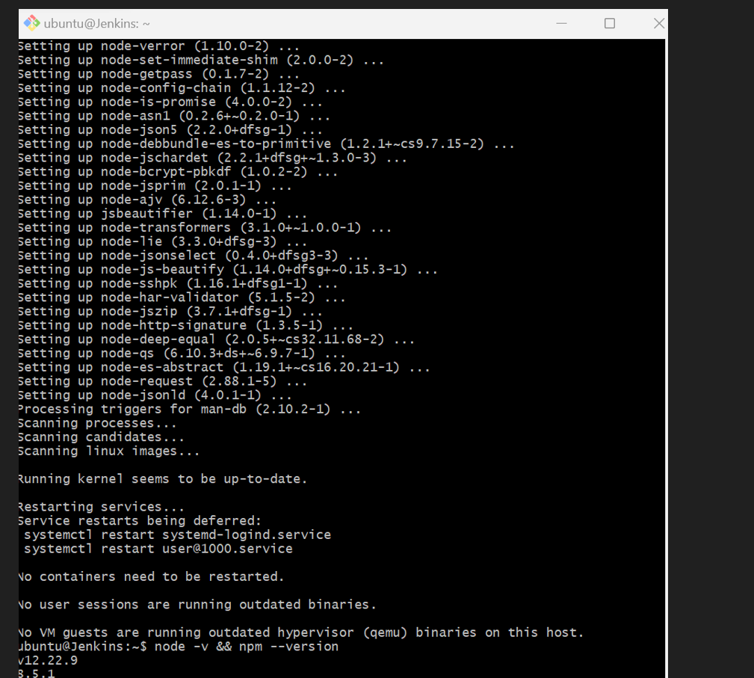

1. **Forked the hackathon-starter into my github repo -** [**https://github.com/nidhyamails/hackathon-starter**](https://github.com/nidhyamails/hackathon-starter)
2. **Installed and integrate Docker into Jenkins along with plugins and setup ECR for docker on AWS.**

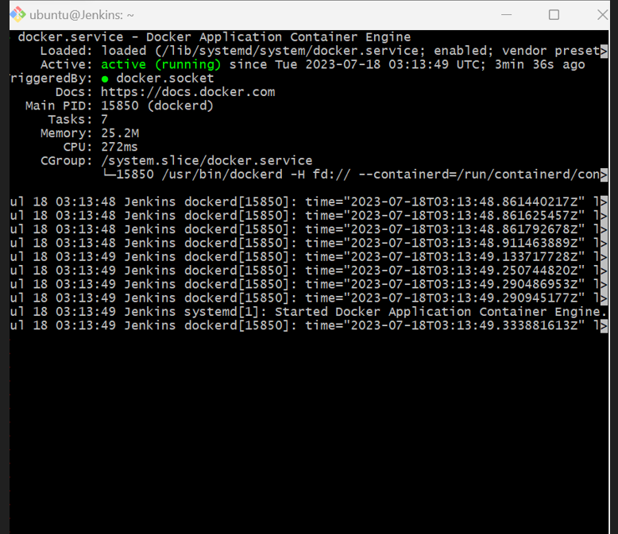

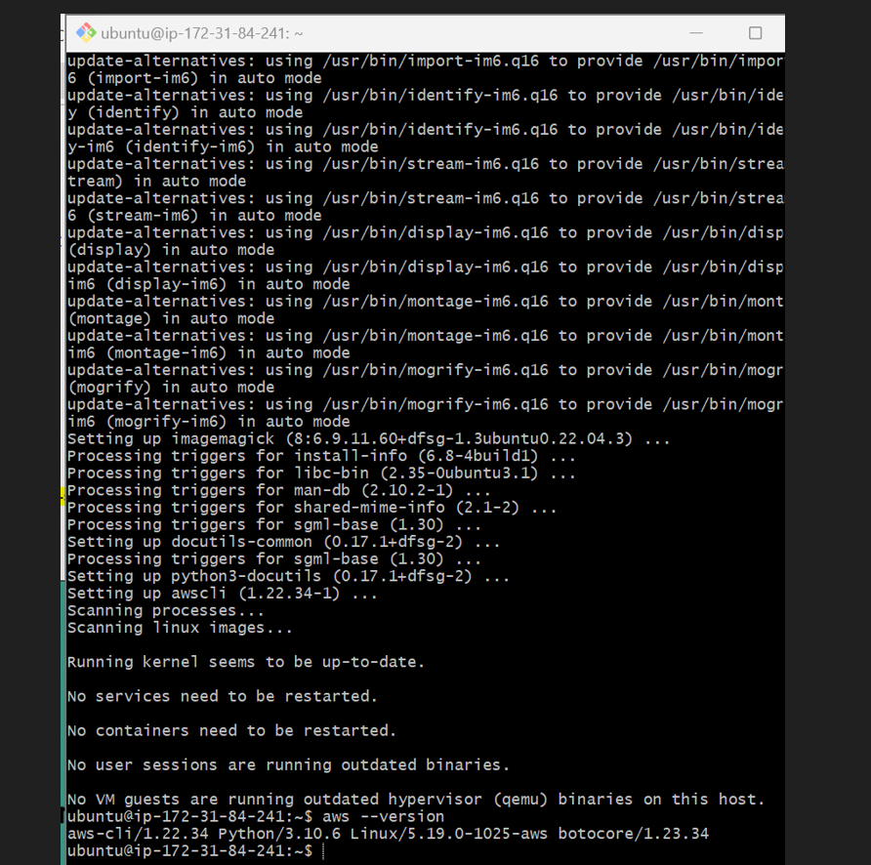

1. Built a docker image using the forked repo

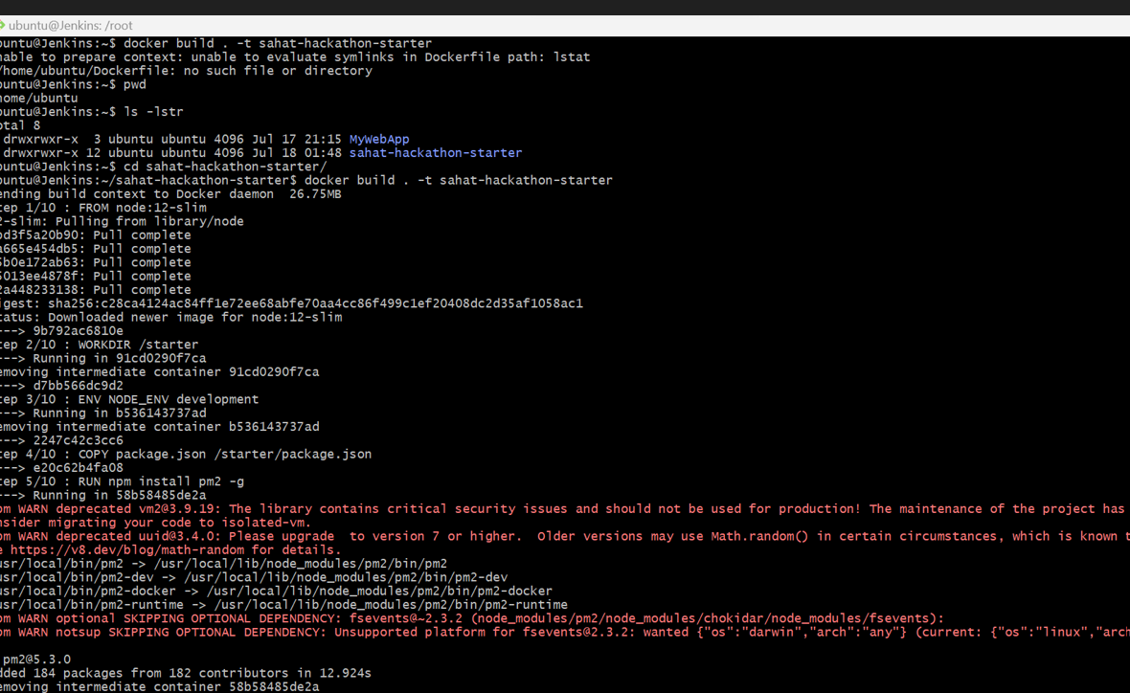

1. Installed and used Trivy to scan images as part of pipeline script – Please refer pipeline scripts in the repo for details and below is the screenshot of installation

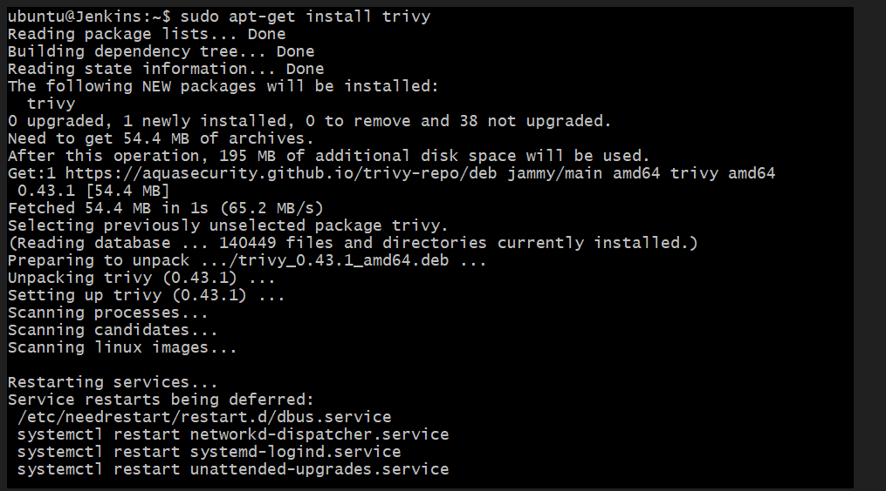

1. Installed and integrate sonarqube in Jenkins for code quality check – Please refer pipeline scripts in the repo for details
2. Installed Kubernetes cluster using EKS

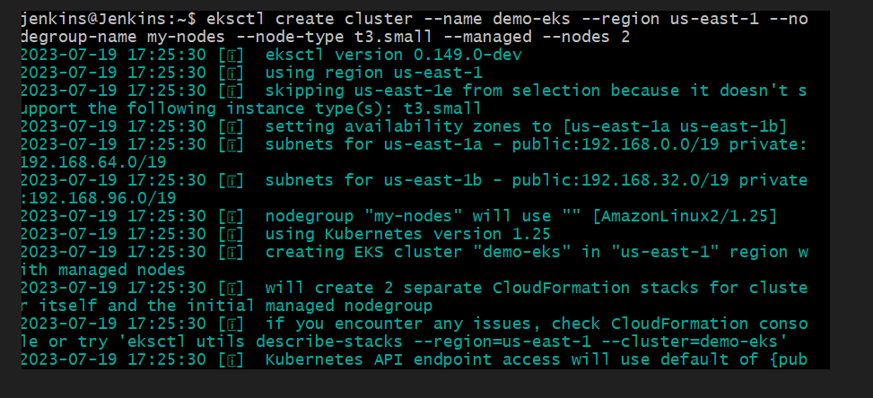

1. Created a pipeline script to checkout,build,Trivy,Code Quality , Docker Run and Deploy to K8S.

Refer jenkinsfile for pipeline script in the repo - https://github.com/nidhyamails/hackathon-starter

1. Install MongoDB using Ansible in EC2 instance

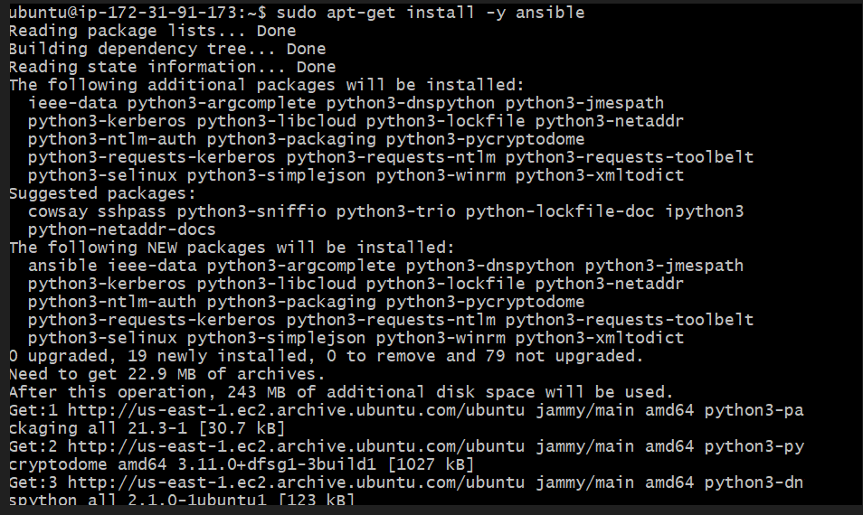

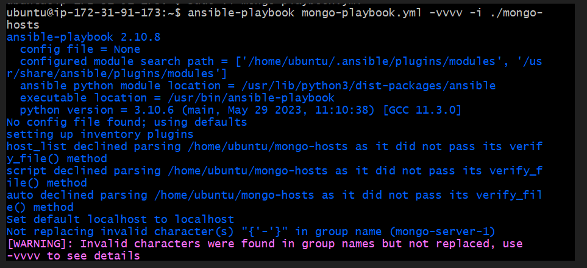

1. Created an EC2 instance using Terraform – Please refer the github repo - <https://github.com/nidhyamails/terraform-code-assessment>

